
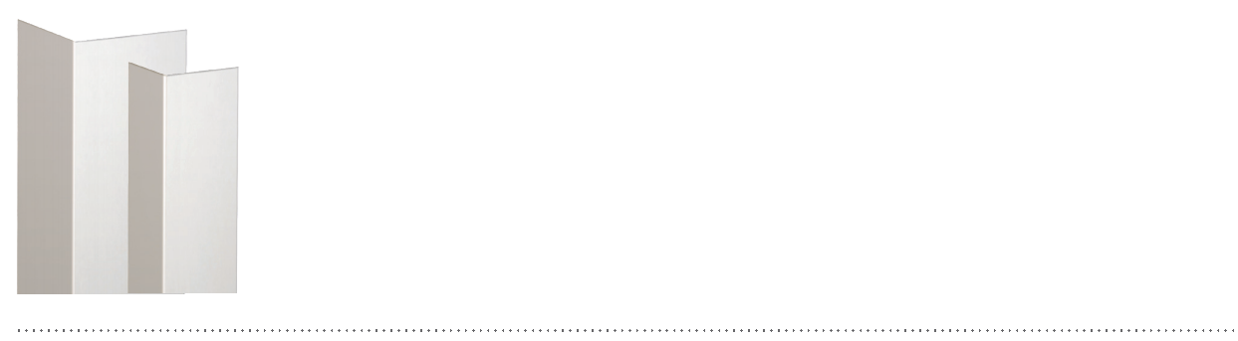
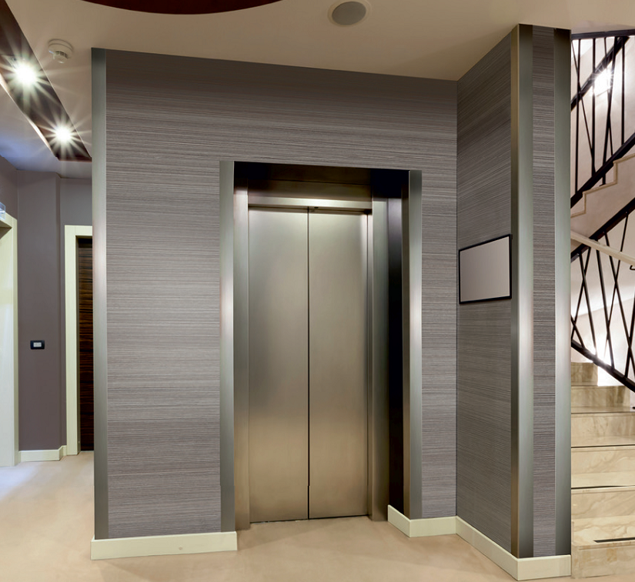

SPECIFICATION

PROFIL’INOX 50 AND 30
90° ADHESIVE CORNER PROTECTORS
IN BRUSHED STAINLESS STEEL
- Description: 90° adhesive corner protector with 50 or 30 mm wings (internal measurement) (Profil’Inox 50 or 30 as manufactured by SPM), 10/10th mm thick in brushed stainless steel approved for food handling areas and provided with two adhesive foam tapes. Wings are lightly beveled. A protective film is specified to minimize cleaning before acceptance.
- Finish: brushed metal.
- Installation method: adhesive. SPM universal mastic glue is recommended for stronger fixing.

